

October
Vol. 1, Issue 1

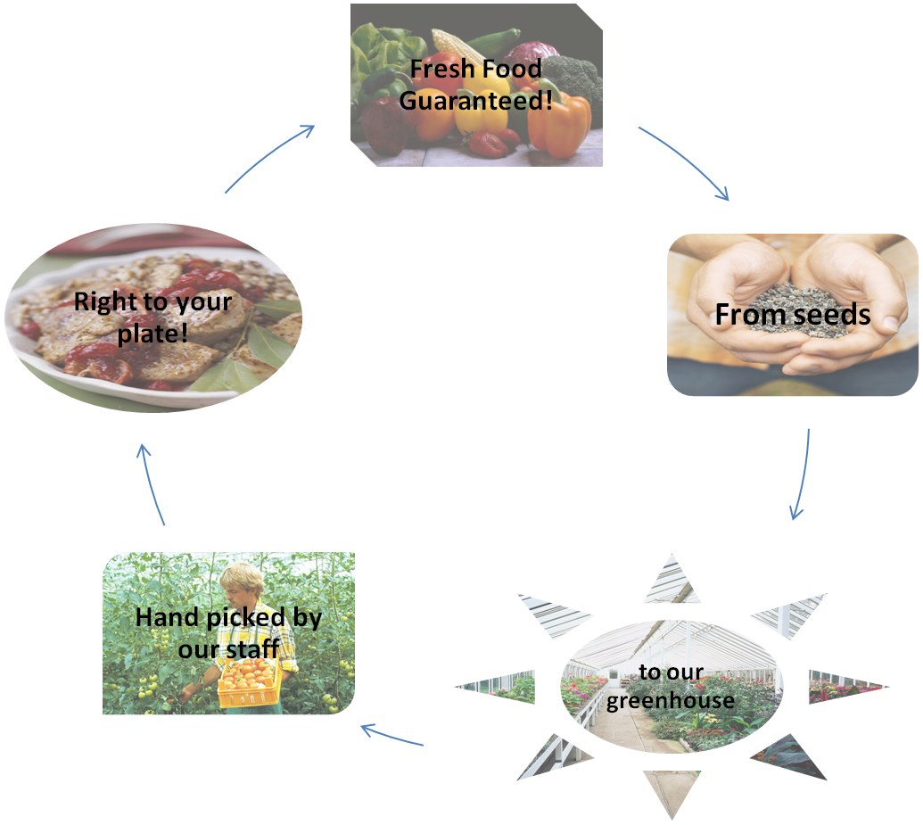
Growing Green Eatery is a restaurant located in Willow Grove Pennsylvania that grows its own produce. We ensure our customers that the food they eat is of the highest quality. No pesticides are used in the growing of our foods so all they ingredients we use are natural. As a result, all the food we make is also low calorie and good for your health. It is perfect diet food, or if you simply want a night out. Growing Green Eatery also has a menu for children twelve years and under and also offers specials to senior citizens on Sundays.
The atmosphere inside of our restaurant is relaxing and family-friendly. Seating inside the restaurant which provides air conditioning and heating. Additional seating inside the greenhouse among our fresh produce is also available. The temperature in the greenhouse is at a constant seventy seven degrees so that our plants have the best possible climate to grow in.
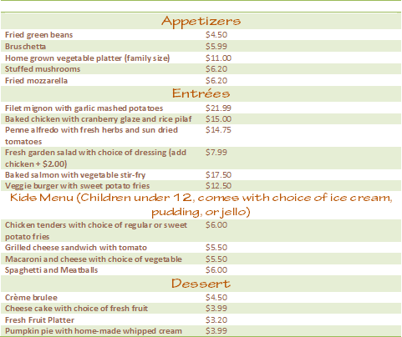
Our staff of gardeners tend our plants daily and are constantly fertilizing and watering them to ensure that they are of the highest quality for our dishes. Our menu changes due to the seasonal fruits and vegetables we grow (see below). Our master chefs change their dishes to capture the elements of every season that you love most and work them into various dishes that you will love.
“At Growing Green Eatery always our top priority”
Live music of various different genres is provided Friday healthy, high quality food is through Sunday to enhance your dining experience. These bands mostly consist of local and undiscovered artists. Growing Green Eatery is always auditioning new groups to play slots, email us at growinggreentogether@gmail.com if you would like to be considered for one.
Our goal is to serve good food that is also good for you. At Growing Green Eatery healthy, high quality food is always our top priority. Our customers mean a lot to us, so we want to provide you with the best eating experience possible. Growing Green Eatery strives to serve great food and save the environment one step at a time. Don’t just go green, grow green.

